SYSTEM DESIGN

Data Flow Diagram / Use Case Diagram / Flow Diagram

The DFD is also called as bubble chart. It is a simple graphical formalism that can be used to represent a system in terms of the input data to the system, various processing carried out on these data, and the output data is generated by the system.

SYSTEM DESIGN :( Admin)
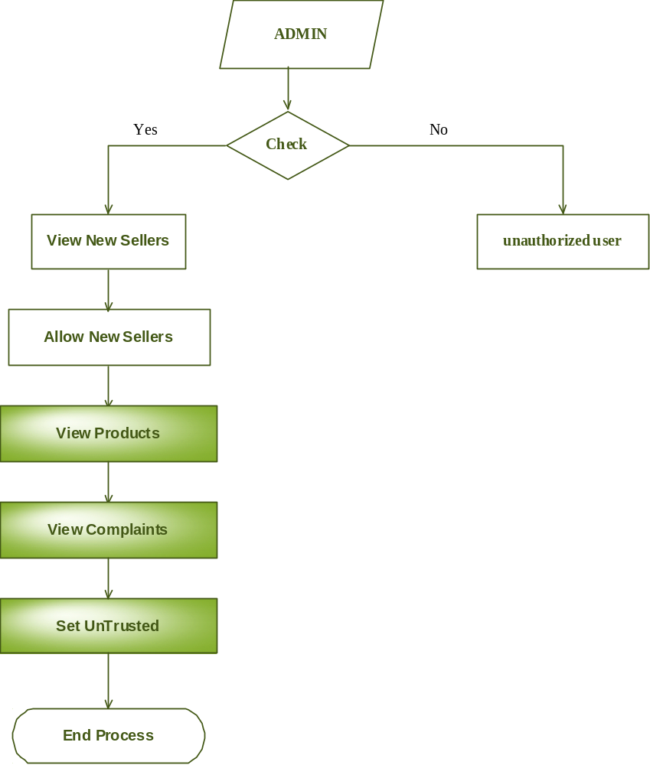

Seller
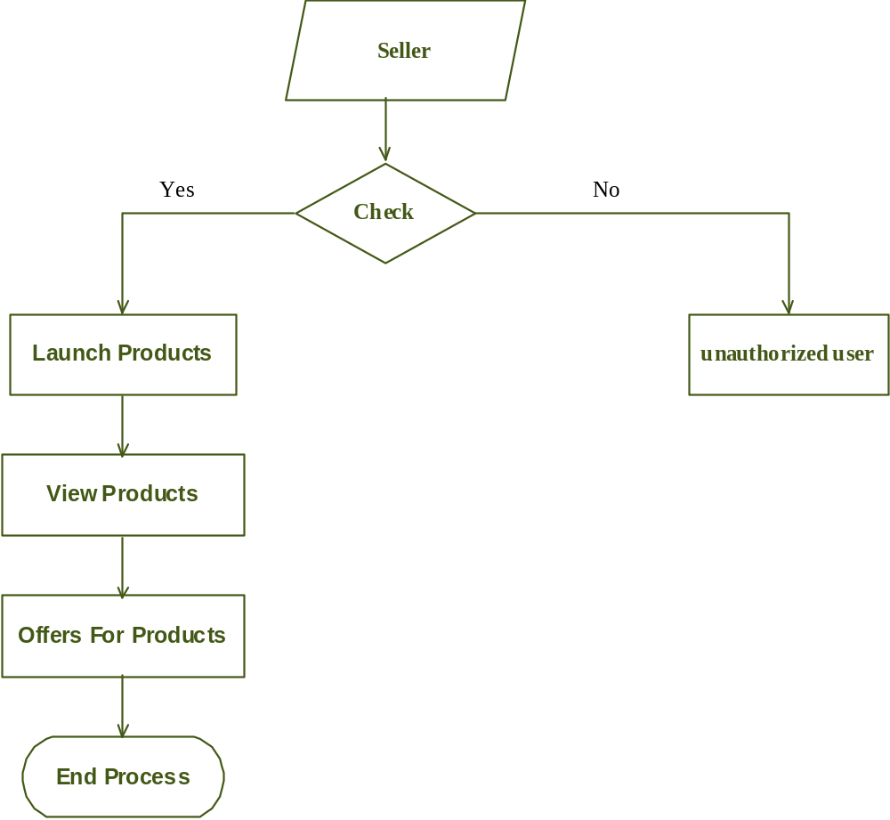

User
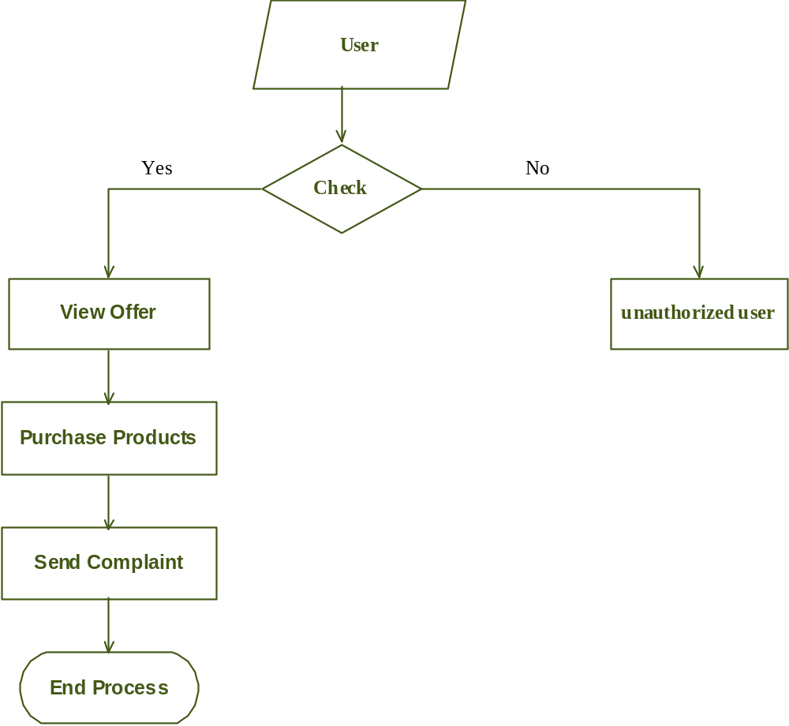

User Case Diagram
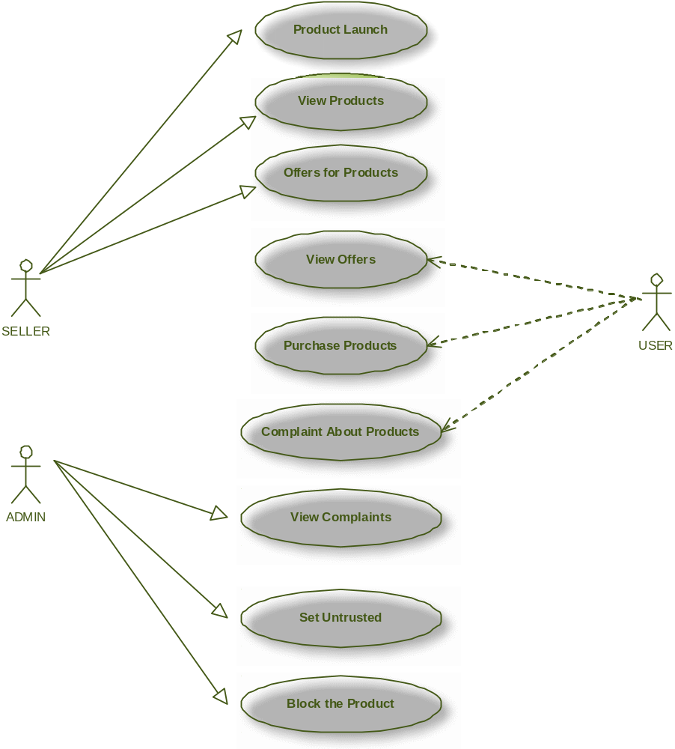

Class Diagram
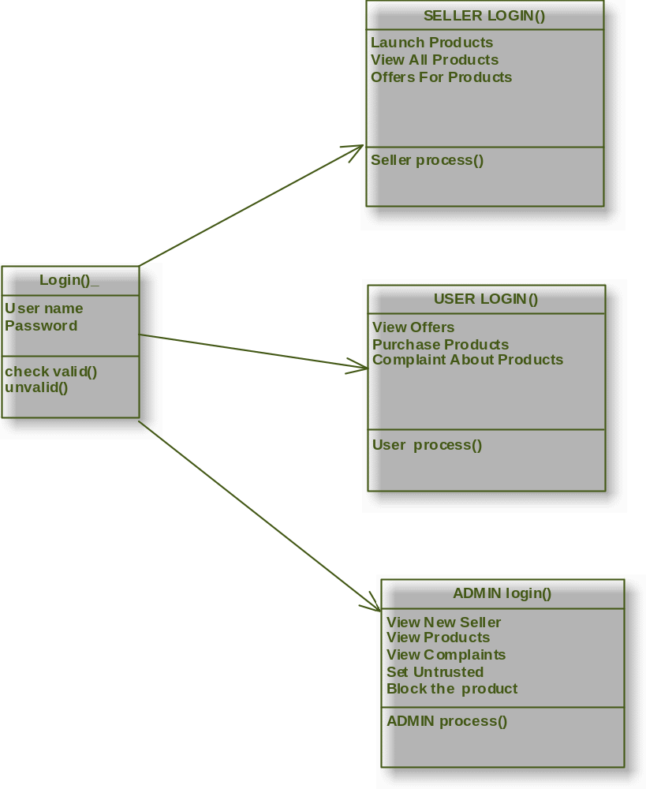

Activity Diagram
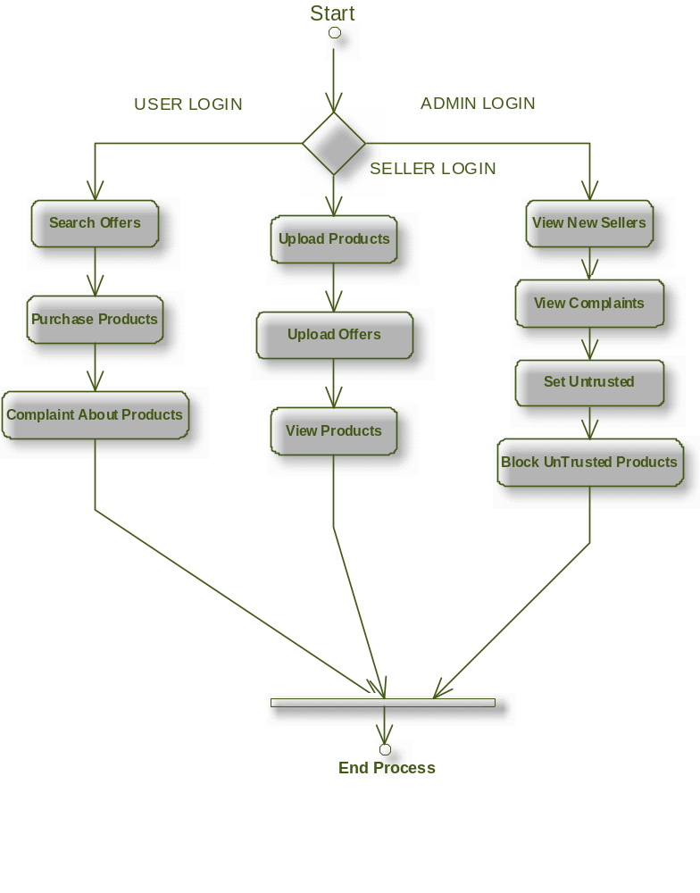

Sequence Diagram

